## To Ungroup a Group

* Select the necessary group.
* Either right click on the group and select **Ungroup Objects**, use the Ungroup icon in the toolbar or use the shortcut key **CTRL + U**.

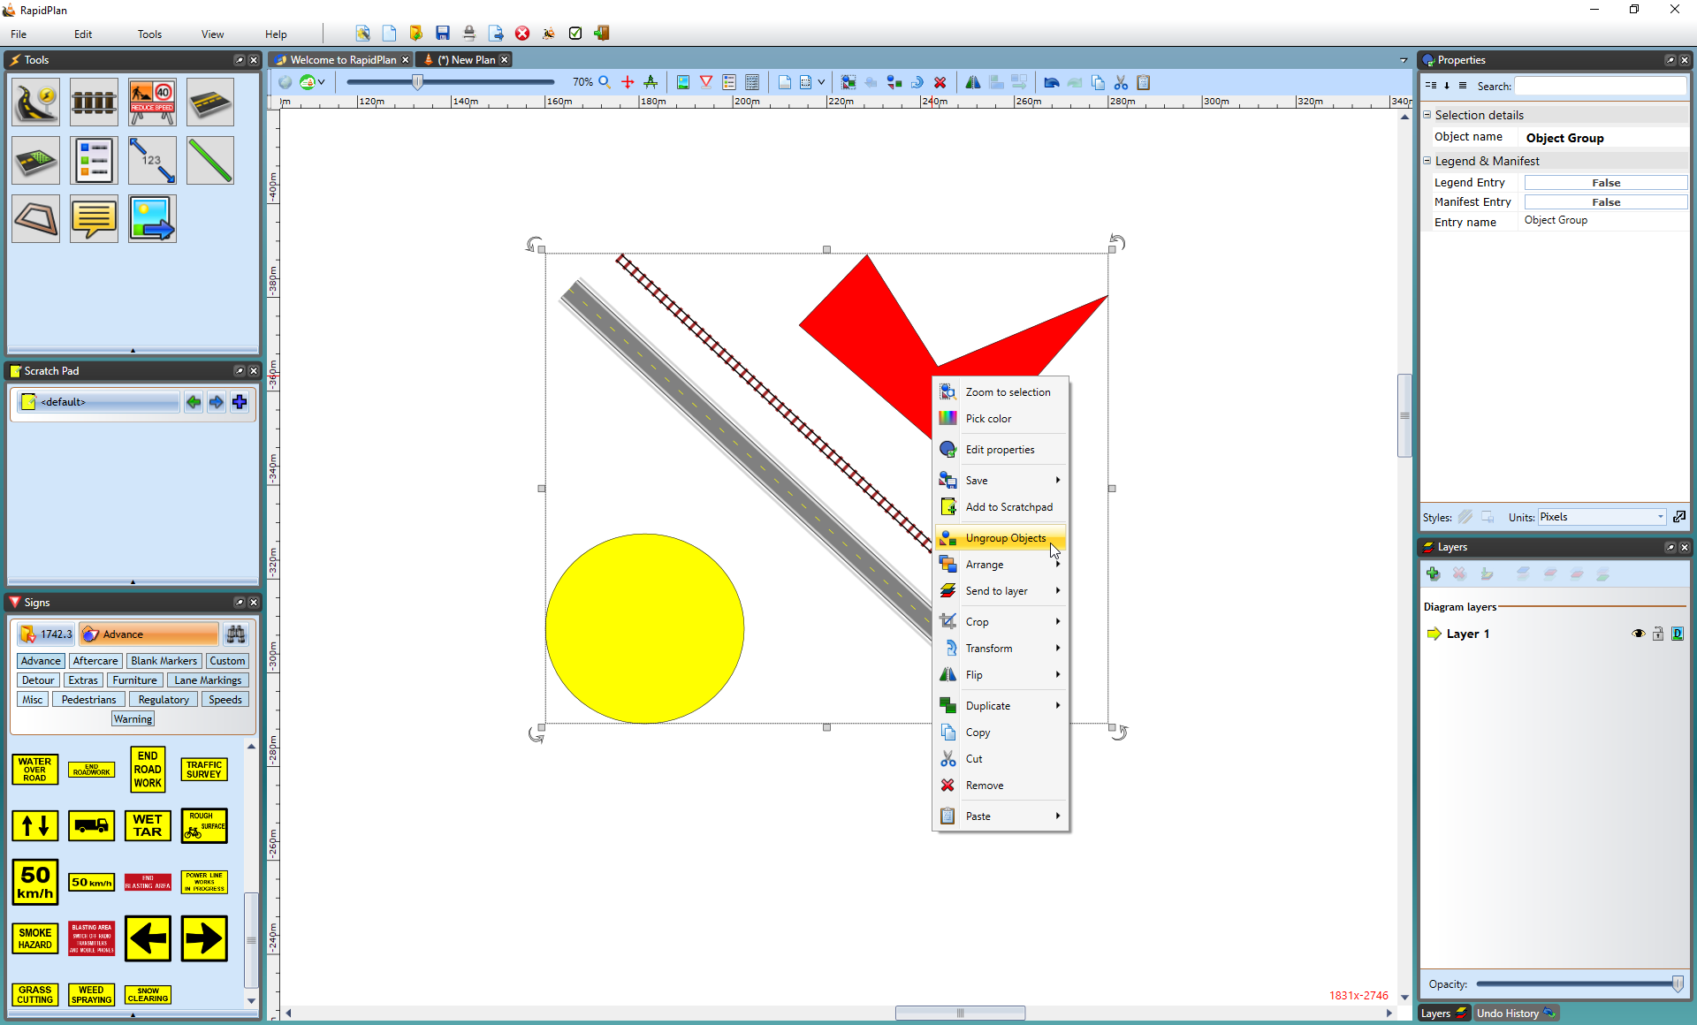

Ungroup_Objects_by_Right_Click

**Note:** Grouped objects can edited without ungrouping. Double click on the group item to launch the quick edit box - you will then have the option to change the properties of a particular object in the group.